Installing SAP GUI:

Step 1: Download and Extract
- Obtain the SAP GUI installation package from the link provided separately
- Locate the downloaded compressed folder and extract all files to a temporary location on your device (e.g., your Desktop).
- Step 2: Run the Installation Wizard
- Navigate to the extracted folder and browse the following directory: \50160634_2 \SAP_GUI_for_Windows_8.00_Comp._1_\PRES1\GUI\Windows\Win64 .
- Right-click on the SetupAll.exe application and select "Run as Administrator".
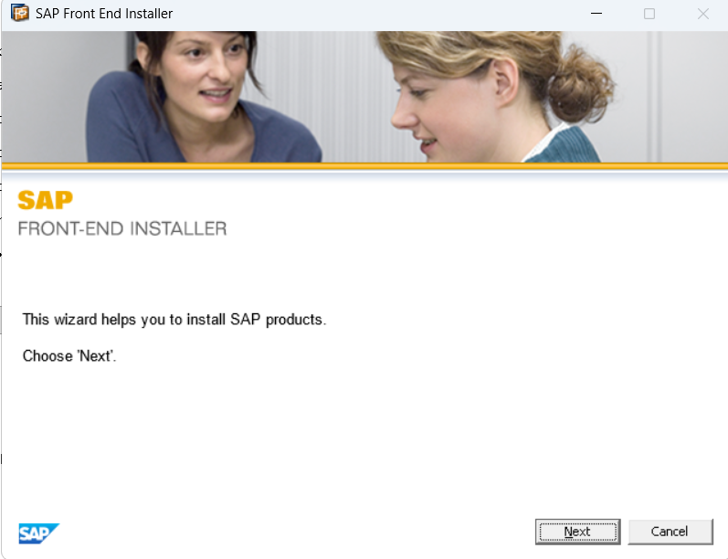
- The SAP Front-End Installer will launch. Click Next.
- Check the box to Select All (or choose individual components like SAP GUI for Windows) and click Next.
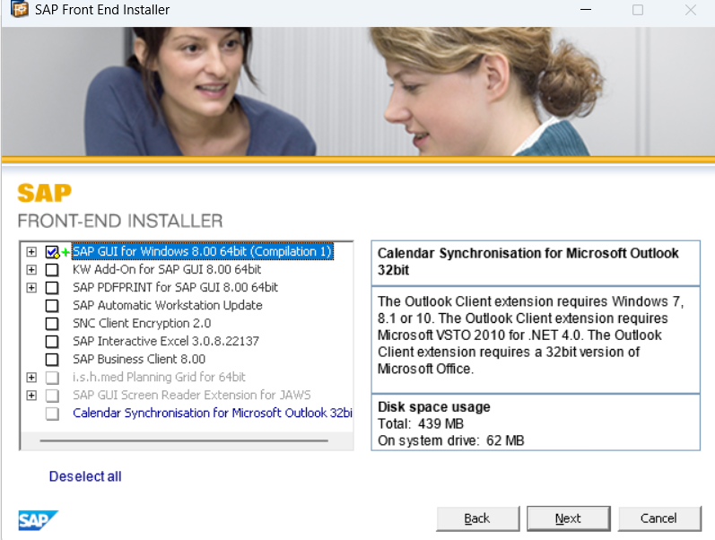
- Select your installation path (or leave the default) and click Next.
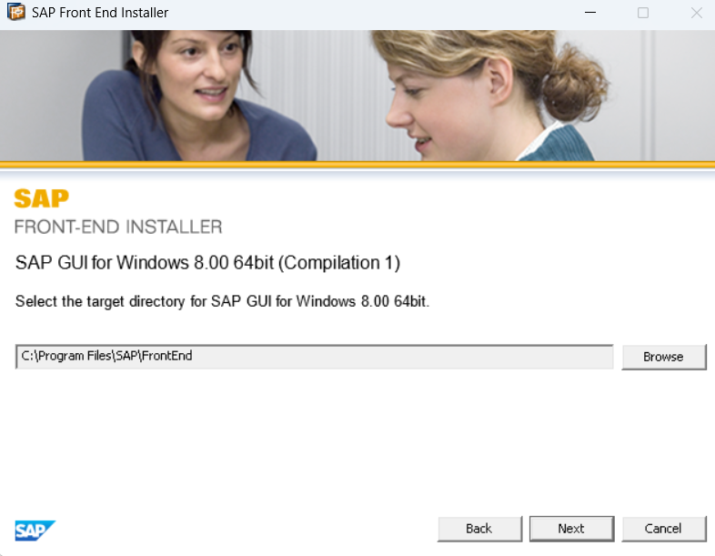
- Once the installation is complete, click Close

Adding Server:
1. Open SAP Logon
- Launch the SAP Logon application from your Windows Start Menu or Desktop shortcut
2. Initiate New Entry Wizard
- Look at the top-left toolbar of the SAP Logon 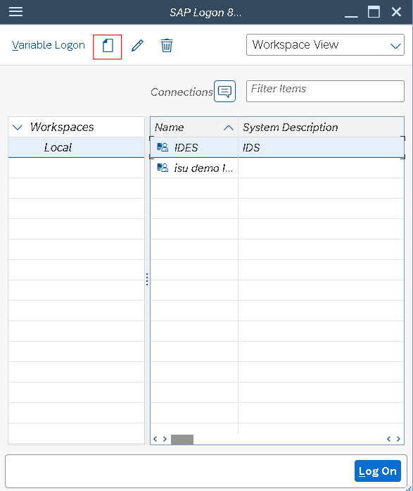
- Click the New Item icon (which looks like a blank white page) and select connection.
- Click Next on the initial system entry screen.
3. Fill in Connection Parameters
- Enter the specific network attributes exactly as provided by your administrator:
  - Description: Type a recognizable name for the server (e.g., SAP Production).
  - Application Server: Type the exact IP address or DNS hostname of the server.
  - Instance Number: Enter the two-digit port number (usually 00).
  - System ID (SID): Enter the unique three-letter system identifier (e.g., PRD, DEV, QAS).
4. Save and Test Connection
- Click the Finish button at the bottom of the window to save your profile.

